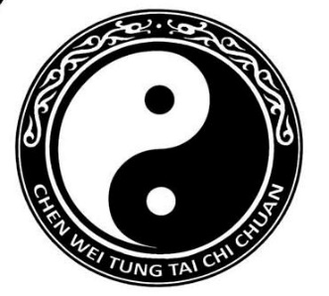

Master Tung Chen-wei’s

New Hampshire Autumn Seminar

November 18 - 20, 2022

Location: Ashland Gymnasium
27 Highland St. Ashland, NH

Dates: Friday November 18th 6:00 - 7:30 p.m.
*Friday evening class is open to new students who know (or can follow) Slow Set
$60 cash fee payable at the door
Saturday November 19th 10:00 - 11:30 a.m.
5:00 - 6:30 p.m.
Sunday November 20th 10:00 - 11:30 a.m.
*Seminar participants are welcome to attend Master Tung’s Sunday class in Concord
located at the IBEW (48 Airport Rd ) 4:00 - 5:30 p.m.

Fee: $300 ($325 if attending Concord class)
RSVP by November 1st

Accommodations:
Fairfield Inn, Plymouth 603-536-0100
Quality Inn, Ashland 603-968-7668
Cold Springs Condos, Ashland 603-536-4600

Complete and return form below with full payment to:
Darcy Cushing
45 Merrill St
Plymouth, N.H. 03264
For further information: (603)536-2068
E-mail: taichiart@gmail.com
---------------------------------------------------------------------------------------------------------------------------------
Master Tung’s
New Hampshire Seminar
Autumn 2022
Name: ______________________________________________________
TOTAL $___________ E-MAIL:________________________________________________________

